Arizona

The State nickname: Grand Canyon State
The State flower: Sagudro cactus flower
The State Animal: Ringtail
The State Tree: Palo Vende
The State Fruit: /

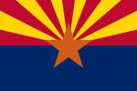
The State Flag:

